1/7/2015 Print



Subject: Olacabs Invoice for CRN 25730010



From: Olacabs Booking (noreply@olacabs.com)



To: yashu_150@yahoo.co.in;



Date: Monday, 5 January 2015 3:13 AM



OLA INVOICE NO.25730010

04 Jan, 2015

OLA yashwanth

Thanks for using OLACABS



|  |  |  |  |  |  |
| --- | --- | --- | --- | --- | --- |
|  |  |  | TOTAL AMOUNT |  |  |
|  |  |  | ₹866 |  |  |
|  | TOTAL DISTANCE: 47.0 Kms | | | |  |
|  | TOTAL WAIT TIME : 15 Mins | | | |  |
|  | OLA MONEY DEDUCTED | | DISCOUNT | PAYABLE AMOUNT |  |
|  | ₹0.0 |  | ₹0.0 | ₹866 |  |
|  |  |  |  | |  |
| FARE BREAKUP |  |  | FARE DETAILS | |  |
| Base fare for 30 kms: | ₹540 | Total Payable Bill | | ₹866 |  |
| Rate for 8.0 kms: | ₹221.0 | TAX BREAKUP | |  |  |
| Wait time charge for 15 Min: | ₹30.0 | Service Tax | | ₹27.03 |  |
| Peak time charge | ₹0.0 |  |
|  |  |  |  |

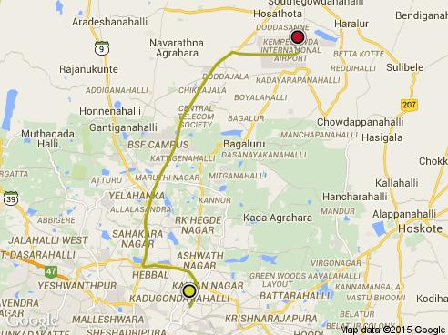

https://in­mg61.mail.yahoo.com/neo/launch?.rand=7dvu7f1291ib2#5073363924 1/2

|  |  |  |  |
| --- | --- | --- | --- |
| 1/7/2015 |  | Print |  |
| Toll Charges | ₹75 | Education Cess | ₹0.54 |
|  |  | SHE cess | ₹0.27 |
|  | BOOKING DETAILS | |  |
| Service type | Bangalore, Cab, Mini |  |  |
| Booking Date | 04 Jan, 2015, 02:03 pm | |  |
| Pickup Date | 04 Jan, 2015, 02:24 pm | |  |
| Booking Email id | yashu_150@yahoo.co.in | |  |



*Minimum bill of ₹540 for the first 30Kms and ₹13/km thereafter. Wait time charges at ₹2.0 per min after first 10 mins , includes waiting time during the trip.

*Total Bill Payable is inclusive of service tax.Toll charges are included in bill.*

For further queries, please write to support@olacabs.com

Note: This is an electronically generated invoice and does not require signature. All terms and conditions are as given on

www.olacabs.com.

A Wing’ Sunteck Centre, 37­40 Subhash Road, Off. Western Express Highway, Vile Parle (East), Mumbai ­ 400057

Service Tax # AAJCA1389GSD001, Service Tax Category Cab Operator, PAN No. AAJCA1389G,​CIN:U72900MH2010PTC240894​ Tel: +91 22 3355 3355, Fax: 022 30947974 www.olacabs.com

©ANI Technologies Pvt. Ltd

https://in­mg61.mail.yahoo.com/neo/launch?.rand=7dvu7f1291ib2#5073363924 2/2